Контрольная работа по английскому языку
5 класс (Вербицкая)
1 четверть.
Данная контрольная работа предлагается учащимся 5-х классов.
Задания контрольной работы составлены по материалам пройденных разделов за 1 четверть.
Каждое верно выполненное задание оценивается в 1 балл. Максимальное количество баллов 30 баллов.
При проверке контрольной работы используется гибкая система оценивания результатов, при которой ученик имеет право на ошибку:
30-28 баллов - оценка «5»;
27-22 балла- оценка «4»;
21-16 баллов - оценка «3»;
15< - оценка «2»

Контрольная работа по английскому языку
5 класс (Вербицкая)
1 четверть.
Your name
1.Напишите глаголы в PresentContinuous
meet – play -
visit – ride -
swim – learn -
send – read -
walk - do –
Score______/__5___
2.Поставьтеглаголывскобкахв Present Simple или Present Continuous.

- Andy sometimes _________________ comics. (to read)
- Boys _________________ football at the moment. (to play)
- My sister usually __________________ in the kitchen. (to help)
- Mum ___________________ a birthday cake now. (to make)
- I _________________ an interesting show now. (to watch)
- We usually ___________________ breakfast at 7.30. (to have)
- You __________________ a computer now. (to use)
- They ______________________ on a plane to America at the moment. (to travel)
- He sometimes ___________________ to the stadium. (to go)
- They __________________ in the sea now. (to swim)
Score______/__10___

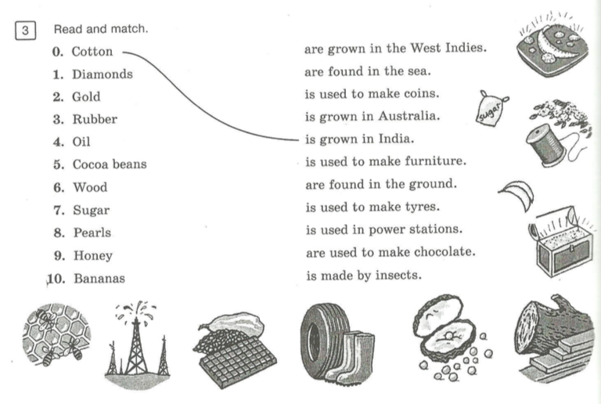

Score______/__10__

4. Заполни пропуски глаголом to be going to, не забудь изменить форму глагола to be.
1. We’ …………………………………... win the first prize.
2.Kate ………………………………………………... enter a photo competition.
3. The magazine …………………………………………………... be in English.
4. Sam ……………………………………………………... think of a new story.
5. You’ ……………………………………………... be the star of my film.
6. Vera and Maxim ………………………………….... make a school magazine
7. I’……………………………………………….. make a film about my school.
Score______/__7__

5.Прочитай и напиши «true» or «false»

Hello, my name is Helen Brown. Only yesterday I was nine and today I’m ten because today is my birthday. And I’m glad that today is Sunday and not Monday or Friday because on Sundays I don’t go to school. But my school friends are coming to my birthday party. It’s 1 o’clock now and my birthday party begins at 2 o’clock. But my friend Kate will come at 3. She and her parents went to see Kate’s grandmother. I already got my present from my parents. It wasn’t a dress like last year or a CD player like the one they gave my brother for his birthday. It’s a bicycle. I like to ride my bicycle. I also like to read. I know that my school friends will give me books with some of my favourite stories. I like books better than videos or music.

- The girl’s name is Mary Brown
- She is nine
- She doesn’t like to go to school.
- Her birthday party begins at 2 o’clock
- Her friends didn’t come to her birthday party, because they were at school.
- Her parents’ present was a CD player
- Helen likes to ride her bicycle.
- She likes books better than videos or music.

Score______/__8__

Total Score______/__30__

